How to Create and Submit a SSO/Bypass, Anticipated Bypass or Extreme Event Report

(Fact sheet) Rev 6/2/26
RIDEM Fact Sheet – How to Create and Submit a Report in NETSEWEROVERFLOW
Overview: Owners and operators of Rhode Island wastewater facilities (collection systems, pumping stations, treatment facilities, etc.) must immediately provide verbal notification of wastewater emergencies and/or sanitary sewer overflows to the Rhode Island Department of Environmental Management (RIDEM), Office of Water Resources' Operations and Maintenance Section (O&M Section).
- If you call during business hours (Monday through Friday, 8:30 AM through 4:00 PM), please call the O&M Section’s wastewater hotline at 401-563-8202.
- When calling to report a wastewater emergency or sanitary sewer overflow, you must speak with a RIDEM staff member. DO NOT leave a recorded message with the details of the event.
- If no O&M Section staff are available through the wastewater hotline, leave your name, community/facility, and a callback number, then try calling members of the O&M Section directly (under the dropdown for Water Resources → Wastewater Treatment Facility - Operations and Maintenance).
- If you call outside of business hours, call the RIDEM emergency hotline (401-222-3070) to report the incident.
Please note that in addition to an immediate verbal report, an electronic report must be submitted to RIDEM through NETSEWEROVERFLOW within five (5) calendar days of the event's discovery.
By signing and submitting the electronic report, the operator is certifying that the information submitted is true, accurate, and complete, and that the operator meets the eligibility requirements to submit reports. The electronic report remains in draft form and has not been completed or submitted to RIDEM until it is certified by the Signatory user.
TO CREATE AND SUBMIT A NEW SSO/Bypass, Anticipated Bypass or Extreme Event Report
- Go to https://cdx.epa.gov
- Type in your CDX User ID and click Next (If you have not migrated your CDX account to Login.gov, please follow RIDEM guidance titled “Login.gov Migration for existing CDX Users”)
OR Create a CDX Account (to create an account, follow the RIDEM guidance titled “Create a New CDX Account with Login.gov” and skip to step 6 below)

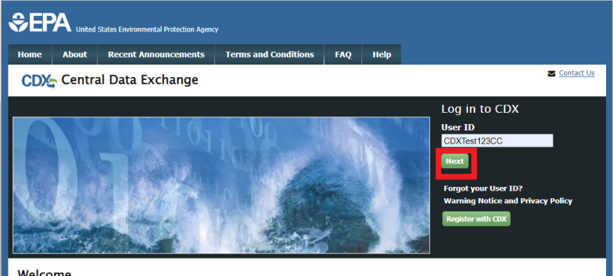
- On the next screen, click “Proceed to login.gov”
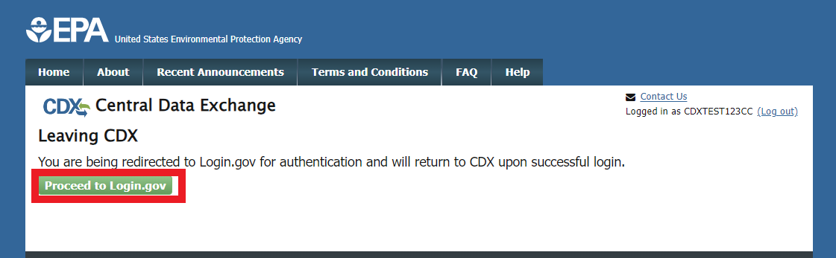
- Enter in the email address associated with your Login.gov account, and your Login.gov password, and click Sign in (at the bottom):
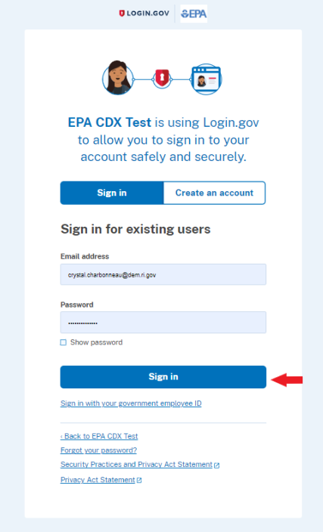
- Enter in the code from your preferred authentication method, and click Submit
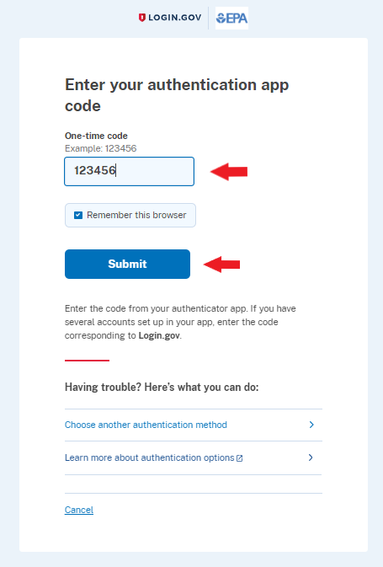
- You will be directed to your CDX Homepage. Open the NETSEWEROVERFLOW program service.
- If you do NOT have access to NETSEWEROVERFLOW, you will need to add the program service by following the guidance How to Add the NETSEWEROVERFLOW Program Service to an existing CDX account.
- If you already have access to NETSEWEROVERFLOW, it will show in your list of available “services” located on your MyCDX home page and your Role (either Preparer or Signatory) will be hyperlinked. Click on your associated Role located next to the NETSEWEROVERFLOW program service name to open the NETSEWEROVERFLOW program service.
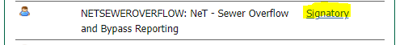
- You will be directed to the NETSEWEROVERFLOW Homepage with a list of facilities you already have electronic access to.

  - If you already have access to your facility NPDES ID on your homepage, select the Actions button to the left of the facility name on your NETSEWEROVERFLOW Homepage
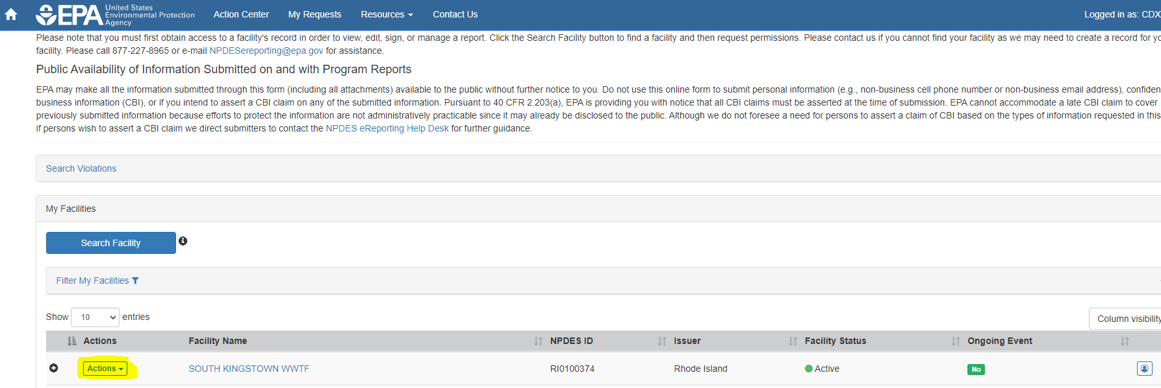
Note: It is possible that you see the facility on your NETSEWEROVERFLOW homepage, but do not have all the necessary permissions (i.e. – sign or DAR sign) to complete and/or certify reports. To review or manage your permissions for the facility, you can select the permissions icon located in the far-right column.
  - If you do not see your facility/NPDES ID on your homepage, you will need to request access (see How to Request Access to your RIPDES Permit(s)/NPDES ID(s) in NETSEWEROVERFLOW). The user with an existing manage permission can approve your request(s). If there is no such user, RIDEM can approve your request(s).
- Upon selecting the Actions button, a drop-down menu will appear. Select “Manage Reports” to open the reports page.
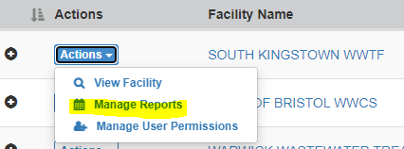
- Click the “Add Report” button to start a new report
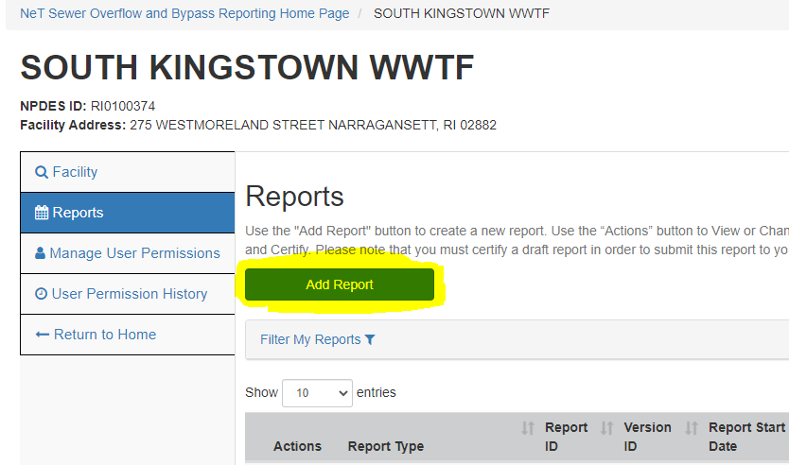
- Select the following answers to the Program Information questions to generate the appropriate report:
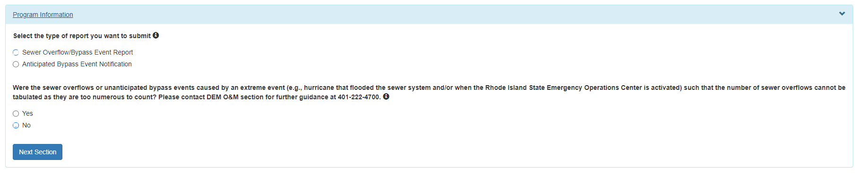
 | Report Type
Program Information Questions | SSO/Bypass | Anticipated Bypass | Extreme Event
Select the type of report you want to submit | Sewer Overflow/Bypass Event Report | Anticipated Bypass Event Notification | Sewer Overflow/Bypass Event Report
Were the sewer overflows or unanticipated bypass events caused by an extreme event | No | N/A | Yes

- Click “Next Section” to create and save a draft of the report 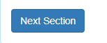
Note: If you must change any of the information in the Program Information section after clicking Next, you will need to start over by deleting the draft form you created and submitting a new form.
- Click “Go to Form” on the pop-up screen to complete the report.

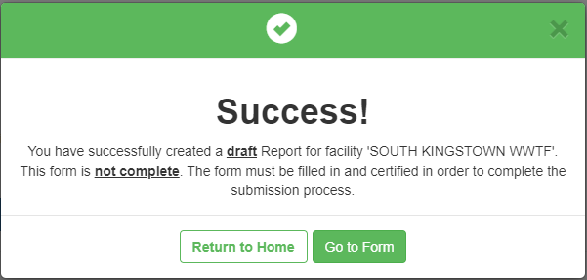

- Please read all of the instructions carefully and complete all of the information (all boxes with an asterisk * are required fields). If a red box appears next to a section that means that section is incomplete. Note: Some sections will be prefilled without the ability to edit.
- Certify the completed form.

Actions Available | Description | Users | Note
Certify Form | to sign and submit form to RIDEM | Signatory | Must have Sign permission for the facility
Flag for certification | to lock information and flag for certification/signature by a user who meets 40 CFR 122.22(a) (form will not be submitted to RIDEM) | Signatory or Preparer | If there are no signatories associated with the facility, the preparer must notify the appropriate individual to Create a CDX Account in order to Certify
No action at this time | no action (your form will not be submitted to RIDEM) | Signatory or Preparer

- If you are a Signatory and are authorized to sign and submit Reports (see 40 CFR 122.22 on who is authorized to sign reports):
  - Select Certify Form and then click Next to complete the submission
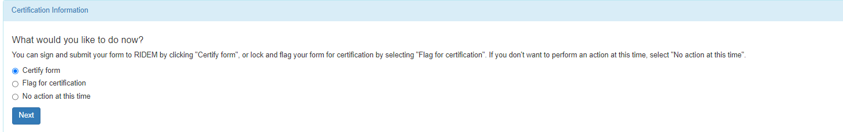
  - Read and Agree to the certification statement by clicking “Accept”
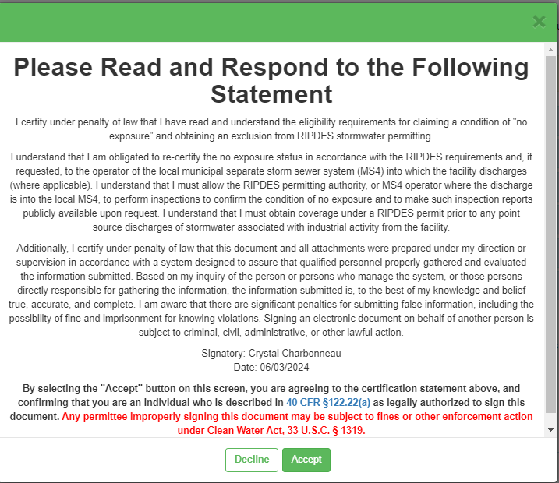
  - A message will appear stating your form has been certified and you will be receiving an email notification once successful.
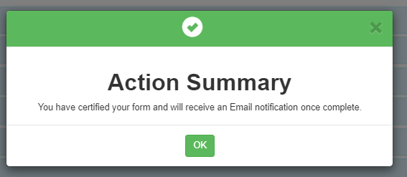
  - Click OK

You will be redirected to your homepage. On the Reports tab, the status of the report you submitted will appear as “Active”
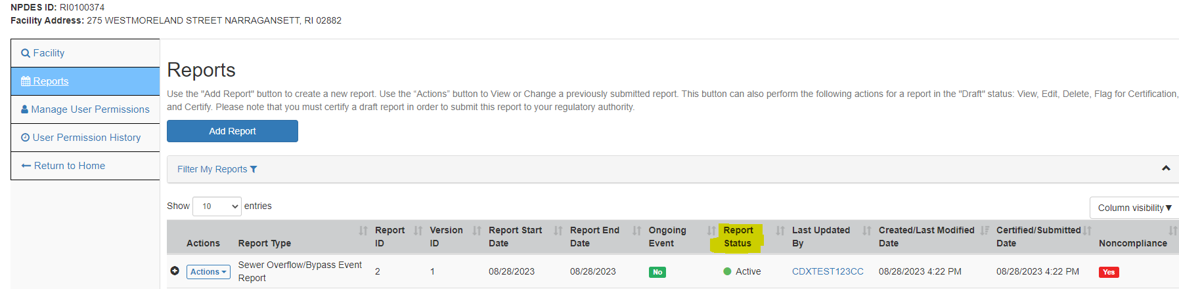
Note: you can select View under the report Actions column to view and print your report submission.
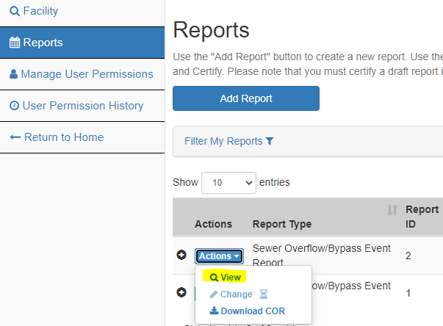

- If you are a Preparer, click Flag for certification. A flagged form is still a draft form and is not complete until it is signed/certified by the individual who meets 40 CFR 122.22.
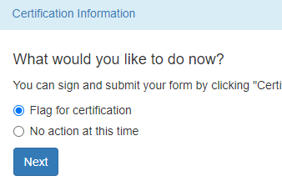
- A pop-up message will appear stating your form has been flagged for certification and must still be certified by the appropriate user. Click Continue
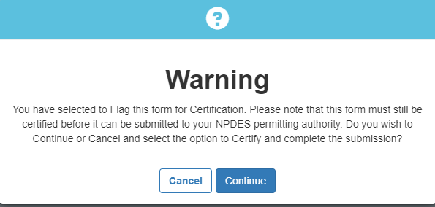

- A pop-up message will appear stating a notification email has been sent to the signatory that has permissions associated with the facility in NETSEWEROVERFLOW. Click OK to continue
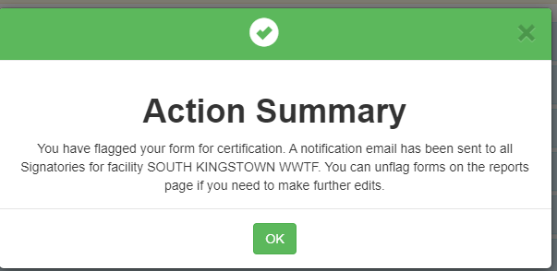
Note: If there are no signatories associated with the facility in NETSEWEROVERFLOW, the preparer must notify the appropriate individual that the form is ready for signature and that the individual must create a CDX account, gain access to the NETSEWEROVERFLOW program service and request permissions to the NPDES ID associated with the draft report in order to certify and complete the submission.

For guidance documents and electronic reporting FAQs, please visit RIDEM’s Electronic Reporting Website www.dem.ri.gov/ripdesErule and EPA’s NeT Support Portal https://usepa.servicenowservices.com/oeca_icis?id=net_homepage
For information on Sewer Overflow Reporting and other O&M related resources, please visit: http://www.dem.ri.gov/wwtf-om

Questions about CDX and NETSEWEROVERFLOW should be directed to the NPDES E-Reporting HelpDesk (NPDESeReporting@epa.gov or 1-877-227-8965). You can also send an email to crystal.charbonneau@dem.ri.gov
If your CDX account is locked or your first/last name has changed, please contact the CDX Help Desk (helpdesk@epacdx.net or 888-890-1995).
Additional questions related to Rhode Island’s SSO/Bypass, Anticipated Bypass and Extreme Event Reporting requirements can be directed to:
Matt Puglia | matt.puglia@dem.ri.gov
Jack Segal | jack.segal@dem.ri.gov

