NWCS Workflow
Nuisance Wildlife Control Specialists Permit
- Customers come in person to DEM office to take a test. Once DEM has confirmed they pass the test they will apply NWCS eligibility to the customer’s profile.
- To Add Eligibility
  - Customer Management > Edit customer profile > Add Eligibility
  - Eligibility Type = NWCS
  - Status = Active
  - Enable Verified
  - Day to Expire from Verification Date should be left blank
  - Date of Test and Score are optional and used for DEM record keeping
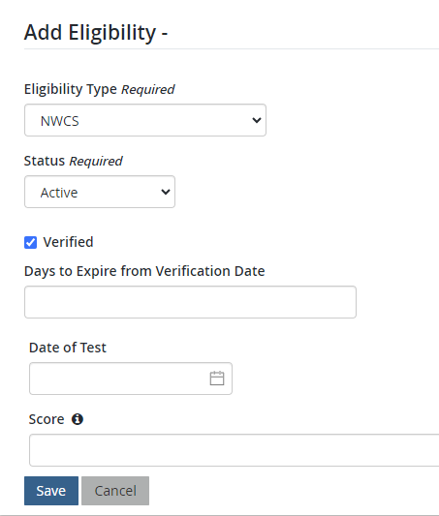
- Once Eligibility is applied the customer will now see the Nuisance Wildlife Control Specialists Permit available in the Hunt/Fish section of the online store.
  - NOTE: steps 2c and 2d are required in order for the product to be available to the customer.
- Once eligibility is added to a customer’s profile they will be eligible to purchase the NWCS permit each year. If eligibility needs to be removed from a specific customer:
  - Look up profile in Customer Management
  - Scroll down to Eligibility section and edit NWCS
  - Change Status from Active to Expired
  - This will not expire any active permit, but will prevent customer from buying the NWCS permit moving forward

